Plenary/invited talk ‘s Information
(Submission Deadline: October 30th, 2023)

1.Your information
a. Title of talk: Energy-efficient AI computing hardware by processing in memory and local learning
b. Full name of speaker: Kyeong-Sik Min
- Academic title: Professor
- Your presentation (please select and put X):

X | Plenary talk |  | Invited talk
- E-mail: mks@kookmin.ac.kr Handphone:+82-10-5699-8310
- Institution (lab/center/faculty, university, city, country):
School of Electrical Engineering, Kookmin University, Seoul, Korea

c. Co-Author (if exitence)
*1st Co-author:
. Full name (English):
. Institution (lab/center/faculty, university, city, country):
*2nd Co-author:
. Full name (English):
. Institution (lab/center/faculty, university, city, country):
*3rd Co-author:
. Full name (English):
. Institution (lab/center/faculty, university, city, country):
…
2. Your Abstract

Abstract: (Preferably detail abstract, include figures and references in ONE A4 page, size 13, Times New Roman, maximum of 200 words)

Large Language Models (LLMs) such as GPT-4 are coming to our daily lives with excellent performance and infinite potential in the field of artificial intelligence. Their enormous size models should deal with a tremendous level of computational workloads that have never been experienced before. The heavy computation needs a huge amount of energy consumption that makes it impossible to sustain the LLMs in terms of computing energy efficiency in future.
How can we improve the computing energy efficiency to keep the LLM’s energy consumption within a sustainable level? After the slowing down of Moore’s law and the end of voltage scaling, one way of reducing the computing energy is decreasing a physical distance between computing and memory units. Processing using memory or processing near memory can be useful to improve the computing energy efficiency by shortening the distance between the logic and memory parts. To explain this in detail, we review various memories including SRAMs, DRAMs, RRAMs, etc. for processing near and using memories to implement AI computing hardware, as conceptually indicated in Figures (a) and (b). Another way of energy-efficient AI computing is replacing the backpropagation algorithm with the local learning one. By doing so, the computational workload of training can be reduced drastically. Based on the discussion above, we can predict what technologies are needed and what direction they should evolve for implementing future AI hardware and summarize this talk.

*Keywords (max: 5):
Processing near memory, processing using memory, AI applications, emerging memories, energy-efficient computing.

Acknowledgements: The work was financially supported by NRF-2022R1A5A7000765, NRF-2021R1A2C1011631, and NRF-2021M3F3A2A01037972. The CAD tools were supported by IC Design Education Center (IDEC), Daejeon, Korea.

*References (max: 10):

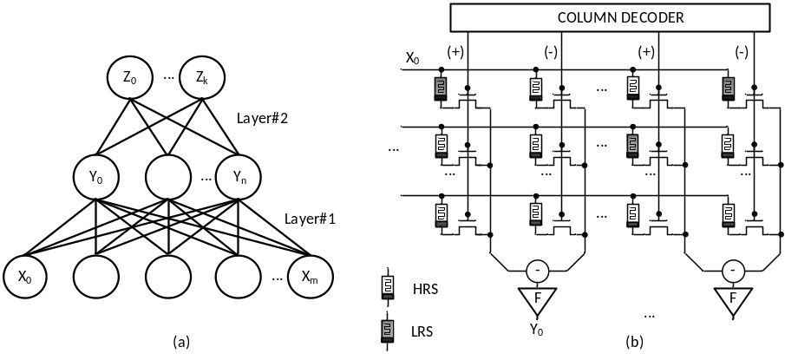
Figure 1. (a) the conceptual diagram of neural networks
(b) the emerging memory crossbar for realizing neural networks

3. Publications
Please let us know your idea (put X) about the publication of your talk in this 4ICEBA2023:
Non-Publication; X
Your power point or PDF file of presentation must be to 4iceba2023@gmail.com before November 15th, 2023.

Publication:
- Your full paper with 4-8 pages (using the full paper template of 4ICEBA2023) send to 4iceba2023@gmail.com before November 15th, 2023 for the peer-review proceess of session presentation.
- Moreover, please select 1 of 4 below Journal which you want to be published. After the 4ICEBA2023, the scientific committee will recommend which jounal will be better for your paper. Then, your updated full paper must submit to website of journal (with its full paper template) for the review process before December 30th, 2023. We will inform you about the publication fee (see its payment instructions firstly). Therefore, your paper will be published as early as February or March 2024.

IEEJ Transactions on Electrical and Electronic Engineering (Scopus, Q3):
. The Institute of Electrical Engineers of Japan

. ISSN: 19314973/Online ISSN:1931-4981

. IF (2022):1.0

. SJR 0.35(2022), Scopus-SJR, Q3 (https://www.scimagojr.com)

. https://onlinelibrary.wiley.com/journal/19314981
. Payment Instructions: https://www.iee.jp/wp-content/uploads/honbu/data-9014/ta04.pdf

IEEJ Transactions on Sensors and Micromachines (Scopus, Q4):
. The Institute of Electrical Engineers of Japan

. ISSN:13475525, 13418939
. SJR 0.21(2022), Q4 (https://www.scimagojr.com)

. https://www.jstage.jst.go.jp/browse/ieejsmas/_pubinfo/-char/en
. Payment Instructions: https://www.iee.jp/wp-content/uploads/honbu/data-9014/ta04.pdf

Applied Sciences (MDPI, Scopus, IF: 2.9, Q1/Q2):
. Switzerland, Multidisciplinary Digital Publishing Institute-MDPI)
. Open Access-free for readers, with article processing charges (APC) paid by authors or their institutions.
. Indexed within Scopus, SCIE (Web of Science), Inspec, CAPlus / SciFinder, and other databases.
. ISSN:13475525, 13418939
. IF (2022):2.7
. JCR-Q2 (Engineering, Multidisciplinary)/CiteScore-Q1 (General Engineering).
. Payment Instructions: https://www.mdpi.com/journal/applsci/apc

Nanomaterials (MDPI, Scopus, IF:5.3, Q1), Special Issue:
. Switzerland, Multidisciplinary Digital Publishing Institute-MDPI)
. Open Access-free for readers, with article processing charges (APC) paid by authors or their institutions.
. Indexed within Scopus, SCIE (Web of Science), Inspec, CAPlus / SciFinder, and other databases.
. ISSN:13475525, 13418939
. IF: 5.3 (2022)& 5-Year Impact Factor: 5.4 (2022)
. JCR-Q1 (Physics, Applied)/CiteScore-Q1 (General Engineering).
. Payment Instructions: please see https://www.mdpi.com/journal/nanomaterials/apc

